IMPROVEMENT OF POWER QUALITY USING DIRECT CURRENT CONTROL METHOD OF STATCOM

This project report is submitted to
Rashtrasant Tukadoji Maharaj Nagpur University

In partial fulfillment of the requirement
For the award of the degree

Of
Bachelor of Engineering in
Electrical Engineering
By

Mr. Pankaj Dhongale Mr. Tinkesh Bhanarkar
Mr. Piyush Ganorkar Mr. Toshik Ghormare
Mr. Sanjyot Ramteke Mr. Takshak Raul
Mr.Tushar Giripunje

Under the guidance of
Ms. Tripti Rai


DEPARTMENT OF ELECTRICAL ENGINEERING
Nagar Yuwak Shikshan Sanstha’s
RAJIV GANDHI COLLEGE OF ENGINEERING & RESEARCH, NAGPUR-441110
(An institution affiliated to Rashtrasant Tukadoji Maharaj Nagpur University, Nagpur)
Session
2018-2019

CERTIFICATE OF APPROVAL

Certified that the project report entitled “IMPROVEMENT OF POWER USING DIRECT CURRENT CONTROL METHOD OF STATCOM” has been successfully completed by TUSHAR B. GIRIPUNJE under the guidance of PROF. TRIPTI RAI in recognition to the partial fulfillment for the award of the degree of Master of Technology/Bachelor of Engineering in Mechanical Engineering, Session 2017-2018, Rajiv Gandhi College of Engineering & Research, Nagpur (An Institution Affiliated to Rashtrasant Tukdoji Maharaj Nagpur University)

Signature
Prof.-Tripti Rai
(Guide)

Signature Signature
Mrs. S. D. Patil Dr. Manali M. Kshirsagar

(HOD, EE Dept.) (Principal, RGCER)

DECLARATION

I certify that

- The work contained in this project has been done by me under the guidance of my supervisor(s).
- The work has not been submitted to any other Institute for any degree or diploma.
- I have followed the guidelines provided by the Institute in preparing the project report.
- I have conformed to the norms and guidelines given in the Ethical Code of Conduct of the Institute.
- Whenever I have used materials (data, theoretical analysis, figures, and text) from other sources, I have given due credit to them by citing them in the text of the report and giving their details in the references. Further, I have taken permission from the copyright owners of the sources, whenever necessary.

(Name of the students) Signature of the Students

1. Pankaj Dhongale
2.Piyush Ganorkar
3.Sanjyot Ramteke
4.Takshak Raul
5.Tinkesh Bhanarkar
6.Toshik Ghormare
7.Tushar Giripunje

ACKNOWLEDGEMENT

We are extremely thankful to our guide Prof. Tripti Rai under whom our project took the shape of reality from mere idea. We are thankful to our guide for enlightening us with his/her precious guidance and constant encouragement. We thank our guide for providing us with ample support and valuable time. We are indebted to our guide who constantly provided a stimulus to reach our goals.
We are grateful to Prof. Sarika Patil, HOD Electrical department, RGCER, for her kind co-operation and timely help.
We express our gratitude towards Dr. Prashant D. Debre, Dean Academics, RGCER, for his never ending support, planning and motivation.
We express our gratitude towards Dr. Manali M. Kshirsagar, Principal RGCER, for her never ending support and motivation.
Lastly, we would like to thank all those who were directly or indirectly related to our project and extended their support to make the project successful.

Name of Projectees
Pankaj Dhongale
Piyush Ganorkar
Sanjyot Ramteke
Takshak Raul
Tinkesh Bhanarkar
Toshik Ghormare
Tushar Giripunje

Table of Contents
CONTENTS Page
No.

Title Page i
Certificate of Approval ii
DECLARATION iii
Acknowledgement iv
Project Work Collaborations / Intra Departments with Certification/ Authentication by Collaboration Partner (If Applicable) v
Table of Contents vi
List of Tables vii
List of Figures …
List of Abbreviations …
List of Symbols
Abstract …
CHAPTER 1 INTRODUCTION 1
  - Overview
1.2 Problem Statement
1.3 Thesis Objectives
1.4 Thesis Contributions …
CHAPTER 2 REVIEW OF LITERATURE
2.1 Overview

CHAPTER 3 WORK DONE :( Report on the present investigation)
3.1 Study of STATCOM 19
3.2 STATCOM Components
3.3 VI Characteristics of STATCOM
3.4 Multilevel VSC topologies for STATCOM
3.5 Controller design for STATCOM

CHAPTER 4 RESULTS AND DISCUSSIONS
4.1
4.2
4.3

CHAPTER 5 SUMMARY AND CONCLUSIONS
5.1
5.2
5.3

CHAPTER 6 – APPENDIX
6.1
6.3 –
6.4 –

CHAPTER 7 – LITERATURE CITED

REFERENCES
LIST OF PUBLICATIONS

Sr. No. | Authors | Title of Paper | Name of International Journals / International Conference | Place and date of Publication with Citation Index

CHAPTER 01
INTRODUCTION
1.1 OVERVIEW
The increasing Industrialization, urbanization of life style has lead to increasing dependency on the electrical energy. This has resulted into rapid growth of power systems. This rapid growth has resulted into few uncertainties. Power disruptions and individual power outages are one of the major problems and affect the economy of any country.
In contrast to the rapid changes in technologies and the power required by these technologies, transmission systems are being pushed to operate closer to their stability limits and at the same time reaching their thermal limits due to the fact that the delivery of power have been increasing. The major problems faced by power industries in establishing the match between supply and demand are:

1) Transmission & Distribution; supply the electric demand without exceeding the thermal limit.
2) In large power system, stability problems causing power disruptions and blackouts leading to huge losses.

These constraints affect the quality of power delivered. However, these constraints can be suppressed by enhancing the power system control. One of the best method for reducing these constraints are FACTS devices. With the rapid development of power electronics, Flexible AC Transmission Systems (FACTS) devices have been proposed and implemented in power systems. FACTS devices can be utilized to control power flow and enhance system stability. Particularly with the deregulation of the electricity market, there is an increasing interest in using FACTS devices in the operation and control of power systems.
A better utilization of the existing power systems to increase their capacities and controllability by installing FACTS devices becomes imperative. FACTS devices are cost effective alternatives to new transmission line construction [1]. Reactive power compensation is provided to minimize power transmission losses, to maintain power transmission capability and to maintain the supply voltage.
Series compensation is control of line impedance of a transmission line; with the change of impedance of a line either inductive or capacitive compensation can be obtained thus facilitating active power transfer or control.

In recent years, voltage stability and control are increasingly becoming a limiting factor in the planning and operation of some power systems, mainly in longitudinal ones. However, a variety of considerations constrains the construction of new transmission lines. This has been reflected in the necessity to maximise the use of existing transmission facilities.
On steady state, bus voltages must be controlled on a specified range. A suitable voltage and reactive power control allows to obtain important benefits in the power systems operation such as the reduction of voltage gradients, the efficient transmission capacities utilisation and the increase of stability margins.
By different control means and operating techniques, the voltage control task in transmission levels can be got; some solution technologies can involve a series voltage injection, or a shunt reactive current injection in strategic sites of the power system. When a disturbance occurs, changes in the voltage system are presented and the restoration to the reference values depends on the dynamic response of the excitation systems and the control devices employed.
In the last decade commercial availability of Gate Turn-Off thyristor (GTO) devices with high power handling capability, and the advancement of other types of power-semiconductor devices such as
IGBT’s have led to the development of controllable reactive power sources utilising electronic switching converter technology. These technologies additionally offer considerable advantages over the existing ones in terms of space reductions and performance. The GTO thyristors enable the design
of solid-state shunt reactive compensation equipment based upon switching converter technology. This concept was used to create a flexible shunt reactive compensation device named Static Synchronous Compensator (STATCOM) due to similar operating characteristics to that of a synchronous compensator but without the mechanical inertia. The advent of Flexible AC Transmission Systems (FACTS) is giving rise to a new family of power electronic equipment emerging for controlling and optimising the performance of power system, e.g. STATCOM, SSSC and UPFC. The use of voltage-source inverter (VSI) has been widely accepted as the next generation of reactive power controllers of power system to replace the conventional VAR compensation, such as the thyristor-switched capacitor (TSC) and thyristor controlled reactors (TCR).

1.2 PROBLEM STATEMENT
The electrical energy is very important for the domestic and industrial purpose.
The electrical power generated by large power plant gets delivered to the customer through distribution system. In three phase distribution system the power quality may get degraded. The main cause of power quality degradation is various types of load. For mitigation of power quality issue various custom power devices are available. The function of power devices is to mitigate power quality issues.Related to power quality there are two types of issues mainly in the system such as Current based and Voltage based power quality issues.These topic mainly focused on current based power quality issues such as reactive power,excessive neutral current,harmonic current,load unbalancing etc. to mitigate such power quality issues STATCOM,custom power device is employed in these project.
1.3 THESIS OBJECTIVE
- Study & Simulation of uncompensated stiff and unstiff system.
- Realisation of Instantaneous Symmetrical Component Theory (ISCT) for reference current generation.
- Application of State Feedback Control for terminal voltage regulation in non-stiff system.
  - THESIS CONTRIBUTION
Chapter 1 deals with thesis introductory part of project.It gives an overview of the work done and the objective of the project. It also discusses the need of the given scheme and the scope of the project work being done and overview of the contents of the different chapters. It also deals with the information related with the different sources of information used in the project work done and the related literature review carried out. It includes different IEEE journals, papers, books and information collected from the other sources.

CHAPTER02
REVIEW OF LITERATURE

2.1 OVERVIEW
Taking into consideration the current as a majority of power quality problem,for its analysis and mitigation the effect of various system parameters and for compensation different effective custom power devices has been already suggested in the literature through various conference papers, journal publication and books. An extensive literature review for analysis and mitigation has been done with brief out in this section.
-The Direct Current Control Method Of STATCOM And It’s Simulation [1].
Static synchronous compensator (STATCOM) is a central device of modern flexible AC transmission system compared with the traditional reactive power compensation device.STATCOM has a advantages of fast response, absorb reactive continuous harmonic current, low loss, small size etc.STATCOM has become an important development direction of reactive power and harmonic compensation.
- Using STATCOM Interfacing Of Renewable Energy Source To Grid And Power Quality Improvement[2].
We use novel idea using Facts devices and interface source to grid propose system Facts device use as STATCOM.
- Improvement of Voltage Quality in AC Network by use of STATCOM -2005Mazurov M.I.,Nikolaev A.V.,Lozinova N.G [3].
As the STATCOM control by PWM controls current of the phase reactor, the problem of compenstion of high harmonic by use of STATCOM can be solve by forming the current containing compensatory components of high harmonic in phase of reactor and in phase of network transformer.
-Application of STATCOM for Harmonic Mitigation and Power Factor Improvement Using Direct Current Control Technique 2017 IEEE[4].
It is observed that this method is complex in implementation as compared to indirect current control method but due to fast response and precise nature of direct current control method, STATCOM acts as a highly proficient device for power factor improvement and harmonic reduction.
-POWER QUALITY PROBLEMS IN INDIA A.S. Pabla Chief Engineer, Punjab State Electricity Board[5].
The consumer satisfaction will be cutting edge in the competitive environment in the 21st century. The right priorities must be set up to solve the various quality problems. By Setting rural co-operatives and professionalisation of power utilities will help to improve the power supply.
- Power Quality and the Need for Compensation
Risha Dastagir, Prof. Manish Khemariya, Prof. Vivek Rai
Research Scholar, 2,3Asst. Professor, Lakshmi Narain College of Technology Bhopal, India[6]
The main reason for reactive power compensation in a system is:
1) The voltage regulation
2) Increased system stability
3) Better utilization of machines connected to the system
4) Reduction in losses associated with the system
5) To prevent voltage swell as well as voltage sag.
-REVIEW OF TRANSFORMERLESS UPFC DEVICE FOR POWER QUALITY ENHANCEMENT IN POWER SYSTEM(International Journal For Technological Research In Engineering february2018)[7]
The definition of power quality is different for the different uses. As per the Institute of Electrical and Electronic Engineers (IEEE) Standard IEEE1100 is “the concept of powering and grounding sensitive electronic equipment in a manner suitable for the equipment.”
-POWER QUALITY IMPROVEMENT IN POWER DISTRIBUTION SYSTEM USING DSTATCOM(2013 Nirma University International Conference on Engineering (NUiCONE)[8]
The STATCOM is three phase shunt connected power electronics based device. It is
connected near the load at the distribution system as shown in fig 1. It is also a one type of the voltagesource converter, which converts a DC input voltage into AC output voltage in order to compensate the active and reactive power needed by the system
-An Approach to Voltage Quality Improvement by Introduction of STATCOM for Distribution System with Renewable Power Generations IEEE PES ISGT ASIA 2012 1569536491[9]
STATCOM technologies for use in the high-voltage transmission system have already been well studied and presently in the step of practical use. However, STATCOM applied to distribution systems requires some other properties such as low cost and simple structure.
-A Voltage-Controlled STATCOM for Power-Quality Improvement( IEEE TRANSACTIONS ON POWER DELIVERY)[10]
This paper considers the operation of DSTATCOM in VCM and proposes a control algorithm to obtain the reference load terminal voltage. This algorithm provides the combined advantages of CCM and VCM.

CHAPTER 03
WORK DONE
1 STUDY OF STATCOM
The STATCOM (or SSC) is a shunt-connected reactive-power compensation device that is capable of generating and or absorbing reactive power and in which the output can be varied to control the specific parameters of an electric power system.
It is in general a solid-state switching converter capable of generating or absorbing independently controllable real and reactive power at its output terminals when it is fed from an energy source or energy-storage device at its input terminals.
Specifically, the STATCOM considered in this chapter is a voltage-source converter that, from agiven input of dc voltage, produces a set of 3-phase ac-output voltages, each in phase with and
coupled to the corresponding ac system voltage through a relatively small reactance (which is provided by either an interface reactor or the leakage inductance of a coupling transformer). The dc voltage is provided by an energy-storage capacitor.
STATCOM is defined by IEEE as a self commutated switching power converter supplied from an appropriate electric energy source and operated to produce a set of adjustable multiphase voltage, which may be coupled to an AC power system for the purpose of exchanging independently controllable real and reactive power.
A single-line STATCOM power circuit is shown in Fig. 3.1, where a VSC is connected- to a utility bus through magnetic coupling. In Fig. 3.1, a STATCOM is seen as an adjustable voltage source behind a reactance—meaning that capacitor banks and shunt reactors are not needed for reactive-power generation and absorption, thereby giving a STATCOM a compact design, or small footprint, as well as low noise and low magnetic impact. The exchange of reactive power between the converter and the ac system can be controlled by varying the amplitude of the 3-phase output voltage, Es, of the converter. 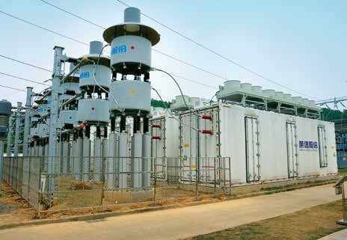
Fig.2. STATCOM

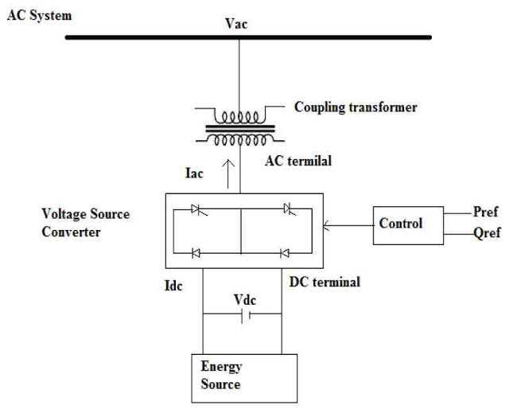

Fig.3.Block diagram of STATCOM

That is, if the amplitude of the output voltage is increased above that of the utility bus voltage, /Et/, then current flows through the reactance from the converter to the ac system and the converter generates capacitive-reactive power for the ac system. If the amplitude of the output voltage is decreased below the utility bus voltage, then the current flows from the ac system to the converter and the converter absorbs inductive-reactive power from the ac system. If the output voltage equals the ac system voltage, the reactive-power exchange becomes zero, in which case the STATCOM is said to be in a floating state. Adjusting the phase shift between the converter-output voltage and the ac system voltage can similarly control real-power exchange between the converter and the ac system.

3.1 STATCOM Components

STATCOM controllers achieve active as well as reactivepower control by injecting current in to the line at the point of common coupling. Saha et al, have presented various topologies and control algorithms for STATCOM . Also, the FACTS program sponsored by Electrical Power Various applications of shunt controllers have been studied and reported in literature . Controllable reactive power can be generated by all types of DC to AC switching converters
(voltage source and current source converters). However due to issues like high conduction losses, additional over voltage protection and higher voltage rating for the semiconductor in current source converter, voltage source converter is popular in power system application like FACTS controllers, especially STATCOM. A controlled three phase voltage of power frequency is produced by sequential switching of power semiconductor devices. The power flow either from line to or controller to line is due to DC charged capacitor at input side of converter. Each output voltage of converter is in phase with line voltage due to small tie reactance linking converter and line. Conventionally two-level VSC are used for STATCOM, however, nowadays multi-level VSC due to its modularity in structure and power handling capability are quickly replacing two-level VSCs for STATCOM.
3.2 The V-I Characteristic

A typical V-I characteristic of a STATCOM is depicted in Fig. 3. As can be seen, the STATCOM can supply both the capacitive and the inductive compensation and is able to independently control its output current over the rated maximum capacitive or inductive range irrespective of the amount of ac-system voltage.
That is, the STATCOM can provide full capacitive-reactive power at any system voltage—even as low as 0.15 pu. The characteristic of a STATCOM reveals strength of this technology: that it is capable of yielding the full output of capacitive generation almost independently of the system voltage (constant-current output at lower voltages). This capability is particularly useful for situations in which the STATCOM is needed to support the system voltage during and after faults where voltage collapse would otherwise be a limiting factor.

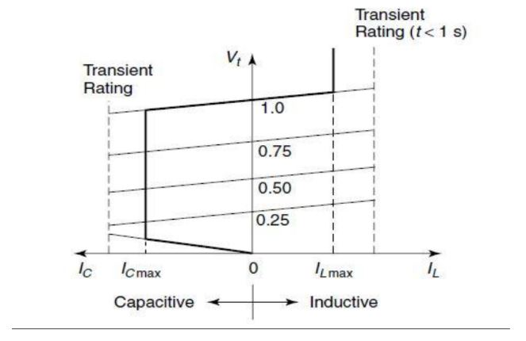
fig 4. VI characteristics of STATCOM

However, when the STATCOM is used for reactive-power generation, the converter itself can keep the capacitor charged to the required voltage level. This task is accomplished by making the output voltages of the converter lag behind the ac-system voltages by a small angle (usually in the 0.18–0.28 range). In this way, the converter absorbs a small amount of real power from the ac system to meet its internal losses and keep the capacitor voltage at the desired level.
3.3 Multilevel Voltage Source Converter Topologies for STATCOM

Multilevel converters have substituted the traditional converters due to structure modularity and low total harmonic distortion (THD). Components required per leg for different multilevel converter topology are listed in table below.

COMPONENT PER LEG OF MULTILEVEL VOLTAGE SOURCE
Converter Type | Diode Clamp | Type Flying Capacitor | Cascaded
Main Switching  Device | (m - 1) x 2 | (m - 1) x 2 | (m - 1) x 2
Main Diode | (m - 1) x 2 | (m - 1) x 2 | (m - 1) x 2
DC Bus Capacitor | (m – 1) | (m - 1) | (m - 1)/2
Balancing Capacitor | 0 | (m - 1) x (m - 2) /2 | 0
Clamping Diode | (m - 1)x(m - 2) | 0 | 0

3.4 Controller Design for STATCOM

For ease the following section is arranged as;
- Pole placement controller technique
- PI / PID/ PD controller technique
- DC-link balancing controller technique
- Hysteresis band controller technique
This however, doesn’t mean that the above mentioned controller techniques are the only solutions. Researchers are continuously updating previous concepts by amalgamating existing one. Pole placement controller design with two set of controller gain i.e. first gain, by the use of linear matrix inequalities (LMIs) to meet design specification and second gain, by the use of zero set to meet overall system voltage control , first gain with one modulation index for steady state and second gain with adaptive modulation index for transient , combine Linear-Quadratic Regulator (LQR) etc. are discussed for improving the operation of STATCOM.
In the environment of damping power systems oscillations, two controllers which regulate DC voltage and AC voltage using the optimal pole shifting (OPS) technique are proposed. Also, the same concept but with fixed modulation index (MI) and variable dc capacitor voltage reference is implemented for STATCOM in . Single machine infinite bus and two area four machine system for damping control by the nonlinear matrix inequalities is proposed in with tested closed-loop performance under three phase fault and small signal disturbances. Reference has come up with the exact linearization method to transform the nonlinear threedimension equations with proportional integral control. Simulation results are derived for STATCOM operation for
three phase ground fault too. A H∞ loop shaping technique for voltage magnitude and angle controller is identified and compared with a PID controller using pole placementmethod for gain derivation. Rule based controller, which utilizes fuzzy logic, bang-bang, root counting theory, selftuning PI with particle swarm optimization etc. are proposed over a fixed parameter PI control to enhance the improved performance of controller Behavior of SSSC and STATCOM on single machine infinite bus and SVC and STATCOM with usual lead – lag controller with particle swarm optimization for dynamic stability performance has been proposed. The result proves that the SSSC offers fast dynamic recovery amongst all three. An adaptive PI controller
is designed to maintain the voltage at point of common coupling for a range of instability. For the intended change in the gain of PI controller a cautious study of previous gain, practical gain and global is done for the algorithm A self-tuning STATCOM with PI controller based on real time data adoption and gain setting with pole placement technique for different loading condition is designed and simulated . A direct axis current control for any PI, PID or Adaptive mechanism is proposed in . Simulation results are compared for controller output voltage variations when reactive power demand does not exceed limits and when reactive power demand exceeds them. Particle swarm optimization technique for AC/DC voltage regulation, AC/DC damping controller, power system stabilizer on the single bus system with several fault condition with
simulation result is investigated in . In transient stability is improved using Euler-Lagrange method based on passivity, where setting of PI controller Kpd=0.01, Kid=0.3, Kpq=2 and Kiq=10 and in a back to back STATCOM based on passivity controller with PWM based
rectifier section and multipulse inverter section is proposed. Whereas in sliding mode technique is adopted where inner loop performs for switching of VSC and outer loop performs for AC and DC side voltage control. A decoupled controller with pole placement technique having an inverter voltage of 480 V and a reference reactive power of 1000 VAR is tested for reactive power change up to 5000 VAR. While doing so the capacitor voltage variation is very small . A
various approach supporting zero set technique, additional current feedback, phase-lead compensation, and series passive compensation, shunt active compensation etc. are conceded to
study system dynamic . In the case of CT behavior is analyzed for cascaded multilevel inverter feedback loop. Voltage compensation at far end of line is experimented by 8 kVA, 415 V STATCOM. The results are strongly matched with speculative framework as voltage sag is reduced by 39% for the STATCOM designed at 25% of rated load , while in an attempt to integrate power converter with digital controller equipped with optical interface is described. This local controller is also capable of sensing signal and sending them back to the power converter via a serial port. Mohan et al. have worked out the issues related to practical implementation of STATCOM for voltage regulation through estimation of load conductance with feedback control. They have modeled STATCOM as an instantaneous reactive current source which controls DC bus voltage with tolerable value of charging and discharging current . Singh et al. has ome up with low THD, 48–pulse, voltage source converter. The uniqueness is achieved by 8 set of double star connected 2–level converter topology. The phase angle difference between two star connections can control reactive power DC capacitor voltage balancing with swapping switching pattern for fixed time period only has been proposed in. Here two series H-bridge five level converter is simulated and tested on prototype. At some instant the swapping of switch may introduce redundant switching loss and phase shift
in voltage. This limitation is overshoot by small signal model and dead band controller where controller is designed to work in capacitive, inductive and standby mode with changing frequency of 120 Hz . A wide area control technique for 12-bus STATCOM is proposed in capable of controlling large power disturbance. At the time of operation, the controller generates
two signals, one for AVR of generator and second for STATCOM. These will together look up the damping of generator rotor during interruption and restoration too whereas in an automatic gain controller is designed for a gain 0< k≤ 1. Stability enhancement with less variation in DC
voltage is the key issue while designing a controller. In an attempt to offer the solution for the above said problem via modified invasive weed optimization (MIWO) algorithm,
back to back STATCOM or loop-shaping technique is presented. A repetitive controller is endowing with the conventional PI controller to trail or refuse the signal with moderate steady state error. For abrupt changes in load the output of the repetitive controller is constant which offers effectiveness in power factor improvement and DC voltage stabilization . STATCOM controller based on RL trial and error is designed. The data is monitored online through six layer fuzzy neural network controller. Floating of DC voltage is a challenging issue for today’s FACTS Controllers. In the focus is on how to improve the drift in voltage for diode clamped multi-level converter by space vector modulation techniques. While managing voltage stability or reactive power compensation, inverter losses and harmonics in a STATCOM is also a question of research. A multilevel inverter with harmonic elimination method is one of the suggested solutions. But these can malpractice with the change in load condition. In the authors had put on the concentration on current harmonics due to resonance, DC
voltage ripple due to firing angle of each switch, consequence of coupling transformer. Also a square-wave controller with current feedback and phase lead compensation is proposed. Differential algebra and a loop shaping method with use of hysteresis band are worked out where pre and post comparator shaped to provide a preferred open loop The best input signal is chosen by inspection. Here a complex perturbation is used to compute optimal control. A seven level cascaded multilevel converter is design as standalone system or H-bridge building blocks technique for 1.5 MVA. This model is capable of handling 4.5 to 30 MVA by adding more number of H-bridges . A ±75 KVAR, 50 Hz, angle-controlled STATCOM was put up for minute operating rang of angle difference between converter voltage and system voltage. The value of angle is set (- 1.5°, 1.5°), hence state-space averaging principal provides more accurate results for reactive power compensation . Similarly root locus method and dynamic voltage controller configurations with negative sequence component and phase voltage magnitude is suggested for steady state and dynamic stability. An adaptive control that counts the ambiguity in the parameter variation is designed and tested for power factor improvement. Author has also compared adaptive controller test results with conventional vector control test results which satisfy the performance of STATCOM in both the case. A comparative analysis is conceded for voltage source converter (VSC) in shunt and series connection applications. Along with this radial basis function network based VSC is proposed and compared with PI controller based VSC for STATCOM, SSSC and UPFC. High power multipulse, multipoint clamped and chain converter topologies are analyzed on basis of no. of devices, total harmonic distortion, component sizing, capability of voltage control and DC voltage drift. Later on, generalized Nconverter module for H-bridge is presented which uses voltage and current harmonic component to stabilize the DC capacitor voltage. Experiments were executed for two and three modules where second harmonic of line voltage has been adopted for injected component . H-bridge cascade multilevel STATCOM with low voltage and 11 kV power rating hardware has been jointly developed by University of Newcastle and ResTech Pty Ltd. Voltage balancing is done by arranging the DC capacitor voltage in incremental order. This will decide the sequence of phase leg to generate the output based on instantaneous real power flow . A nonlinear controller based STATCOM on multi-machine power system is designed and simulated for three-phase to ground fault at two different nodes . A special purpose STATCOM for Spallation Neutron Source power beam accelerator at Oak Ridge National Laboratory has been effectively implemented for full rated power . Also for regulation of bus voltage a system stabilizer based on STATCOM is designed on computational optimization approach. ±100 MVAR, 132 kV, 48–pulse, 2-level STATCOM is designed to locate at midpoint of line. The reason behind midpoint location is that it requires only four transformers which further reduces size and cost. In superconducting magnetic energy storage coil is integrated with STATCOM operation for three phase to ground fault. The operation of the proposed STATCOM is simulatedfor voltage control as well as frequency control model. A space vector based 3–zone, 5–zone and 7-zone, PWM technique has been carried out by Narayanet al. The proposed work is to reduce current ripple for inverter used in high-tension lines. Few converters reported for Adjustable speed drives (ASDs), are also reviewed to analyze their probable application in STATCOM. A concept of 5-level inverter has been implemented by cascading one 2-level and one 3-level inverter. Mahadevan et al. team has suggested phaseshifted dual source matrix converter topology.

CHAPTER 04
RESULTS AND DISCUSSIONS
4.1 INTRODUCTION
The simulation results of the compensated and uncompensated system is explained in this section.The system parameters used for simulation study are given in Table 1. The source voltages are assumed to be balanced and sinusoidal under all conditions. In addition to unbalanced linear load, a three phase uncontrolled bridge rectifier is used as non-linear load. The whole system is evaluated under the MATLAB environment. The result obtained given below.

4.2 UNCOMPENSATED SYSTEM

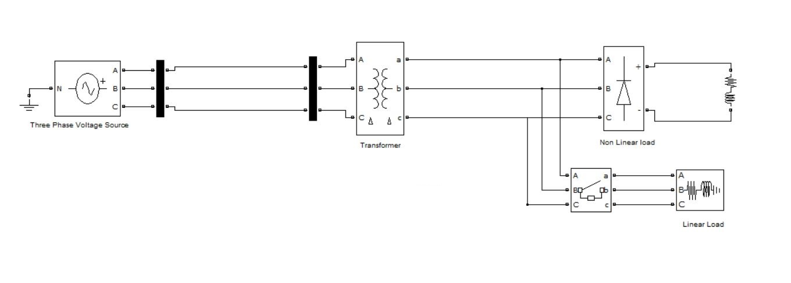
Fig.5. Block diagram of Uncompensated System

4.2.1 Simulation Resuls for Uncompensated System

- Waveform For RL load
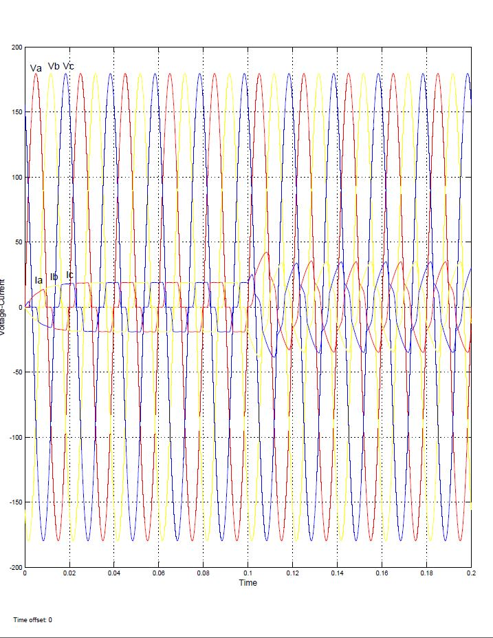

- FFT Analysis for RL load

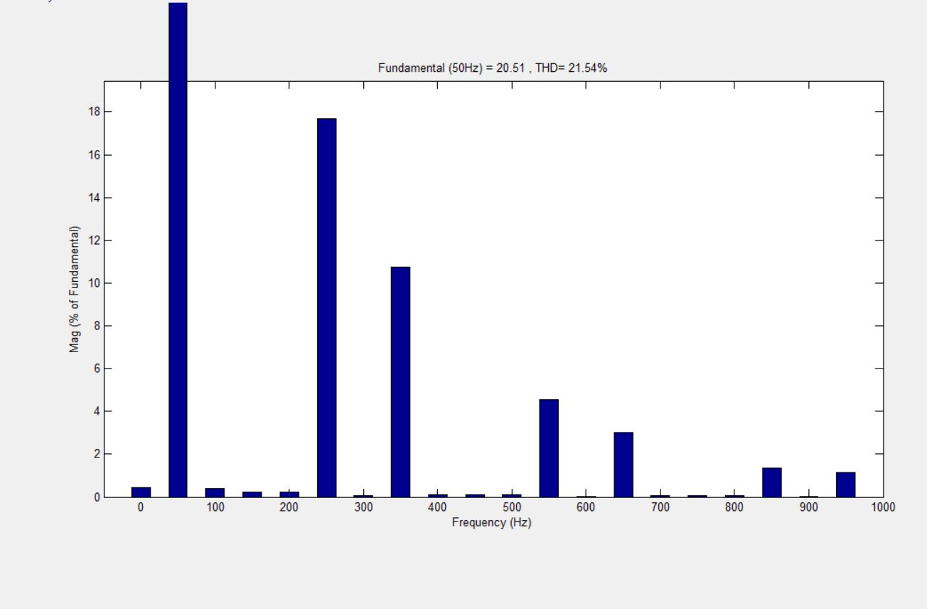
Fig.(a)
- Waveform for Capacitive load

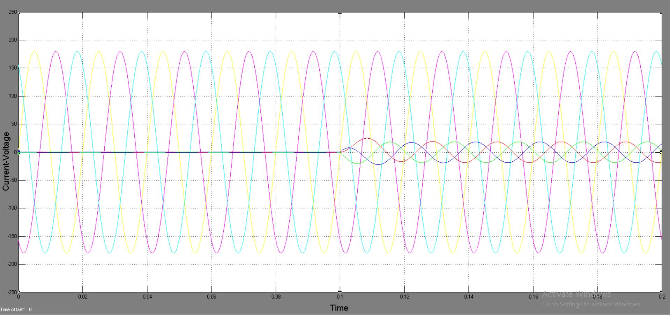

- FFT Analysis for Capacitive load

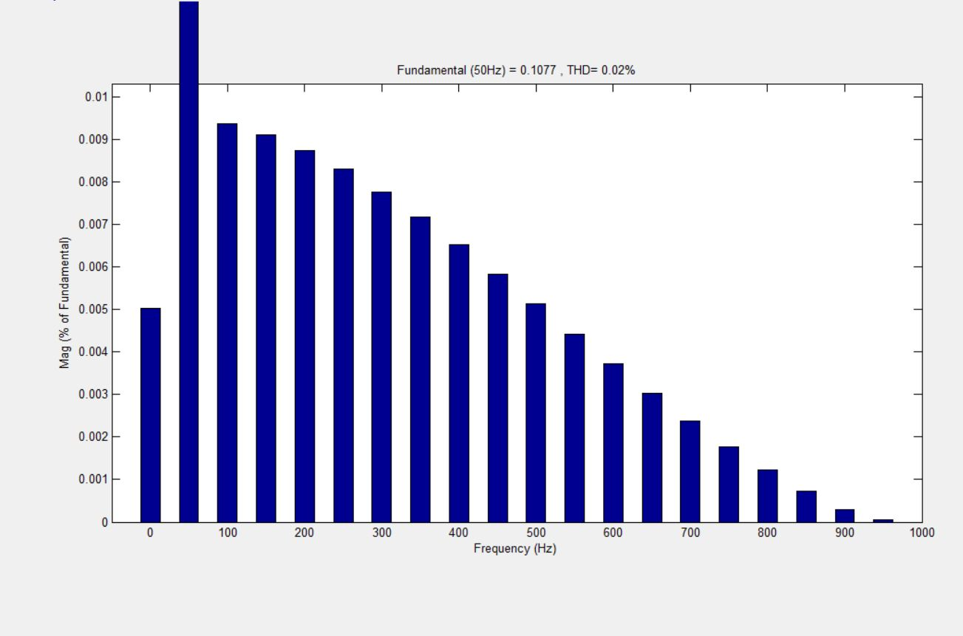

Fig (b)

4.3 COMPENSATED SYSTEM

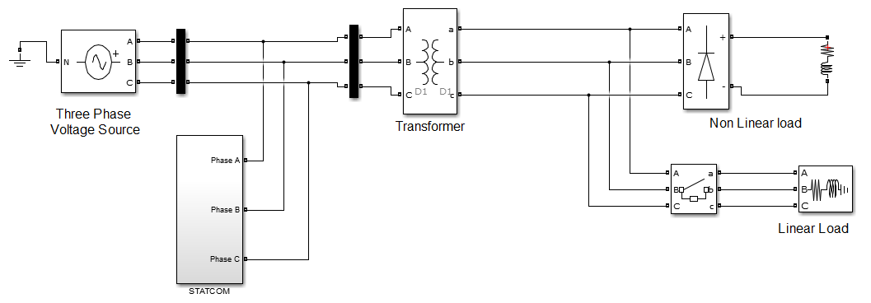
Fig.6. Block diagram of Compensated System

    - Simulation Results after Compensation

- Waveform for RL load

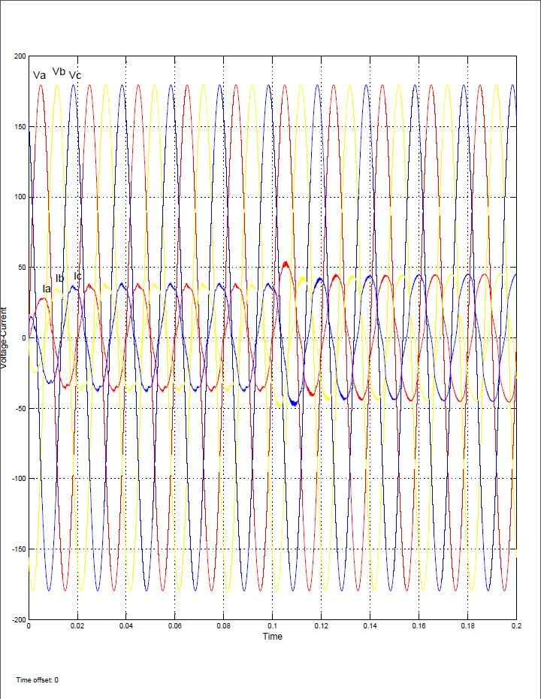

- FFT Analysis For RL load

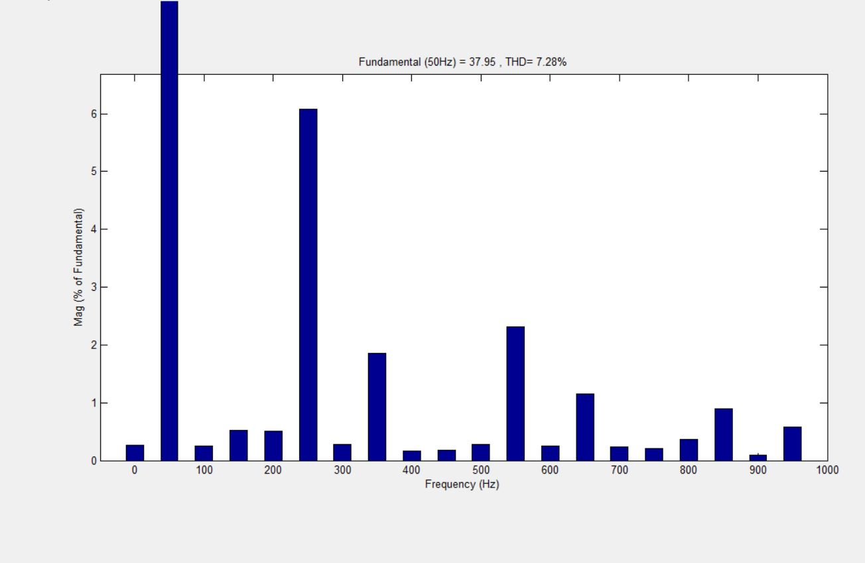
Fig (c)

- Waveform for Capacitive load

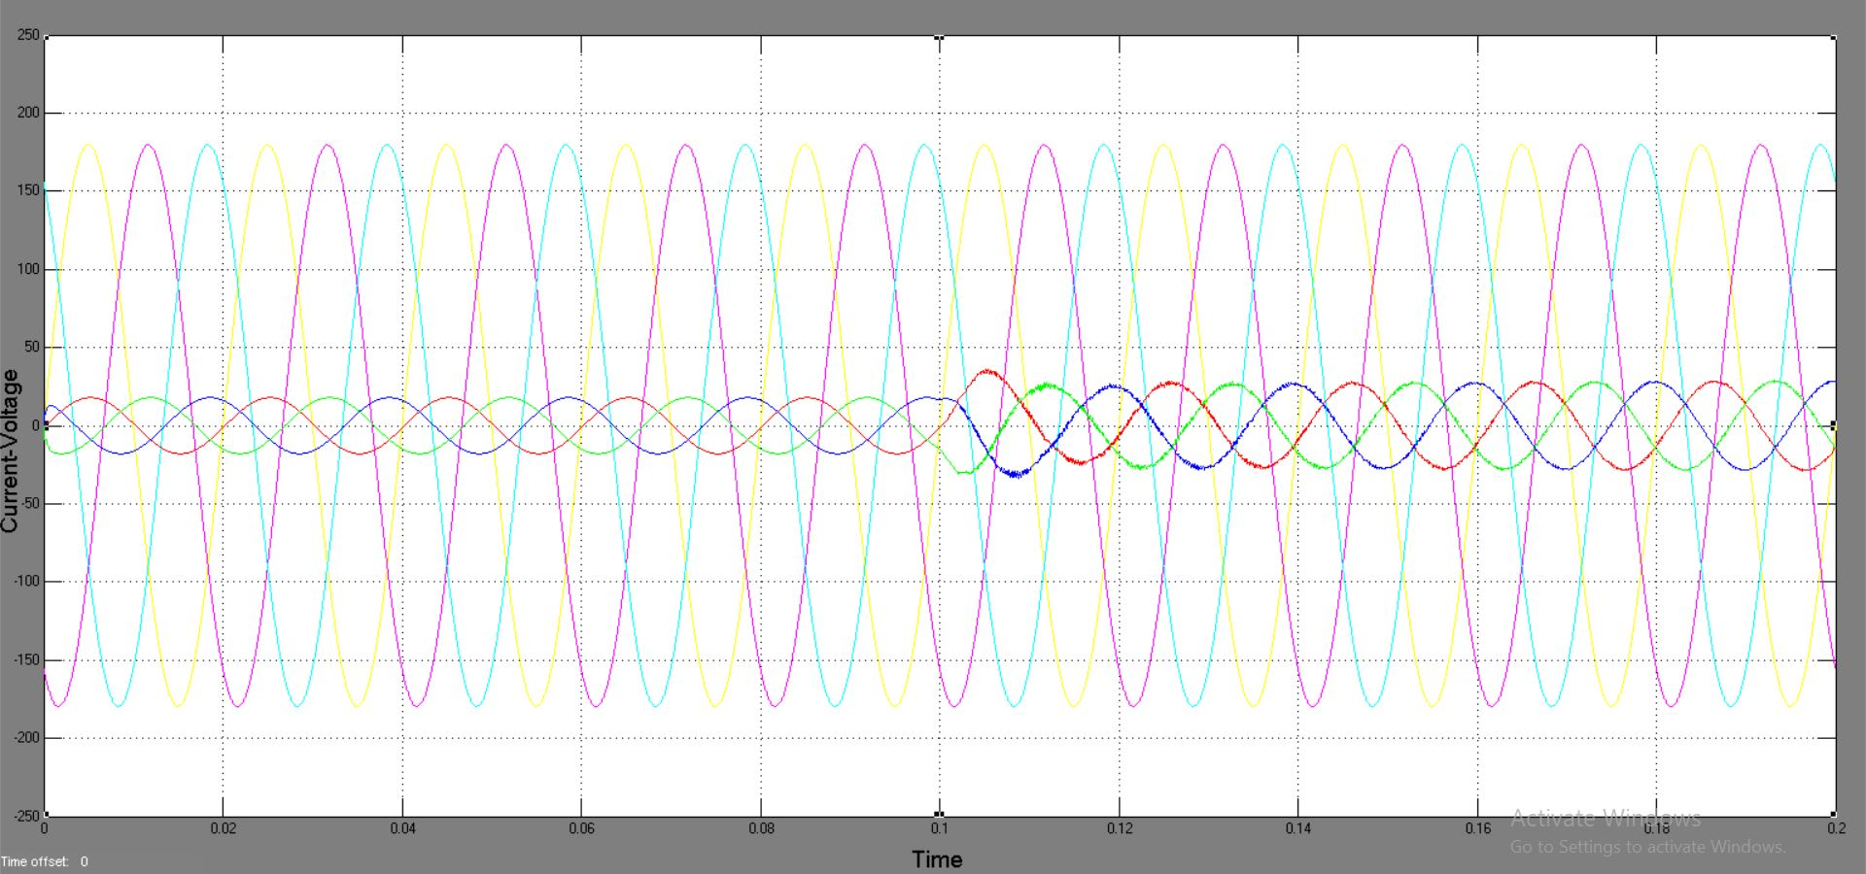

- FFT Analysis for Capacitive load

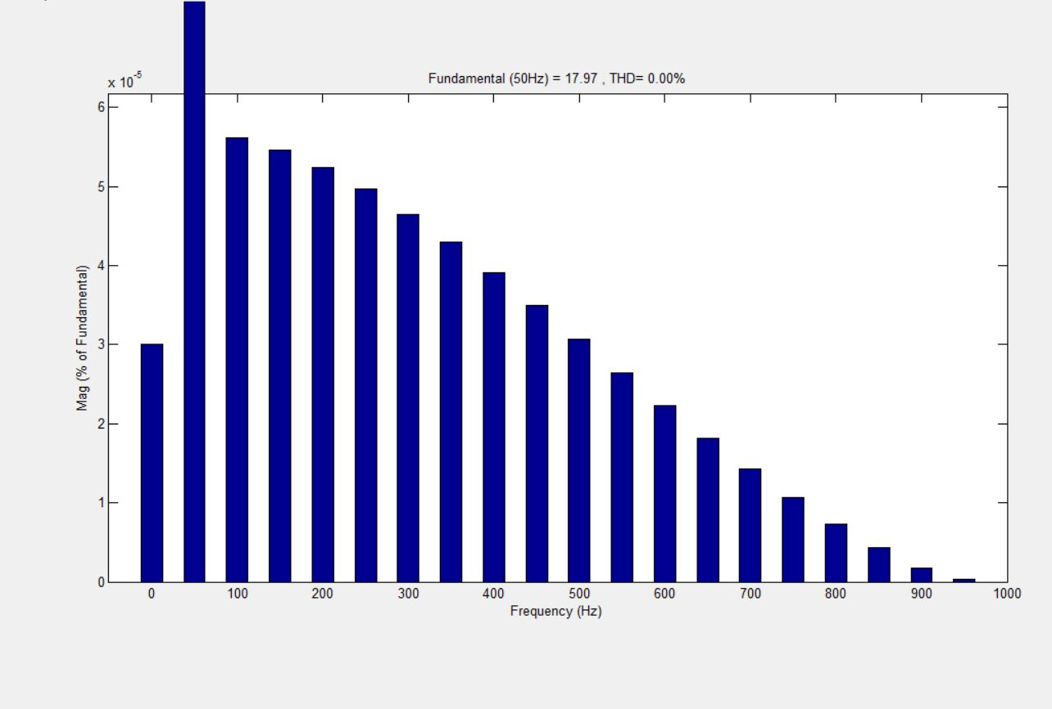
Fig (d)
RESULTS:

Before Compensation
RMS Voltage (Volts) |  |  | RMS Current (Amp) |  |  | Power Factor |  |  | %THD
Vsa | Vsb | Vsc | Isa | Isb | Isc | a | b | c | a | b | c
132.2 | 116 | 132.1 | 24.97 | 23.49 | 21.5 | 0.7871 | 0.6387 | 0.6873 | 21.5 | 21.7 | 21.53

After Compensation
RMS Voltage (Volts) |  |  | RMS Current (Amp) |  |  | Power Factor |  |  | %THD
Vsa | Vsb | Vsc | Isa | Isb | Isc | a | b | c | a | b | c
132.2 | 116 | 132.1 | 35.62 | 31.38 | 31.66 | 0.9201 | 0.8517 | 0.8966 | 7.27 | 7.36 | 6.87

CHAPTER 5
SUMMARY AND CONCLUSIONS

5.1 SUMMARY

This section gives the present scenario os transmission system. It also gives an overview of the present day power quality problems present on the transmission system and complete information about current based power quality issues.
This section also explains the study of various power devices such as STATCOM, IGBT and PI controller. These devices are used for providing reactive power and current in the line and thus improving power quality in the transmission line.
Also, the system deals with various components in the transmission system with the sinusoidal representation , made of operation with the sinusoidal pulse width modulation. Also represent the three phase system configuration for linear and non-linear load.
At last this will also give the total idea about the state feedback control scheme. The switching pulses for the VSI are generated using SPWM technique which is comparatively a fast response one.

5.2 CONCLUSION

The major objective of this research was to present the possibilities, detailed features of STATCOM. The entire STACOM based system is modelled in MATLAB/Simulink. This project contributes in a compensated and uncompensated system, under the presence of unbalanced non-linear loads. The STATCOM application in the three-phase system is to mitigate power quality issues.
When STATCOM is in operation, significant improvement in power quality is observed. Issues like harmonic distortion of the current, power factor voltage profile are properly tackled . So, the power quality is maintained at the point of coupling. The current and voltage at source side are observed in phase after the STACOM is made on into the system. Therefore, a near unity power factor can be maintained at the transmission lines and source end.
Shunt Controller STATCOM provide more reliable and simple control as compared to other controller like SVC. A sine PWM-based control scheme has been implemented to control the electronic switches in the two-level VSC used in the STATCOM. This scheme is ideally suitable for low voltage custom power applications. And also the grid current is almost sinusoidal and the % THD has been improved from 21.54 to 7.28. and thus the power factor of the uncompensated system was 0.623 and after the compensation, it is like 0.93 , which is leading towards unity.
The proposed model is implemented by using MATLAB SIMULINK software and the obtained resultant waveforms are evaluated and the system stability effectiveness and the power system performance ahs been established.

